Introduction
Other than in ST1 post one (where it is recommended that there are two ES meetings), the requirement for the others is one ES meeting per post. However, you might want to consider having two meetings if:
- You feel the trainee is a bit of a concern or
- You feel the trainee needs educating further on using the e-portfolio (and thus setting future good behaviour)

The supervision meeting can take quite a bit of time (anywhere from 1-3 hours). Some ES’s prefer to do the groundwork at home before the meeting whilst others prefer to do it all in the presence of the trainee. Decide what works best for you. Remember to make notes as you go along so you can easily ‘cut and paste’ it into the e-portfolio’s embedded ES form (tip: you can open two e-portfolio windows, one to review and the other to write).

This ES document is long because of necessity; it indicates how important the ES is in GP training. Therefore the document is designed to ensure we all cover the important bits. Going through each section in turn will make it easier to use.

Use the ES review form inherent within the e-portfolio to record the outcome of your ES meeting. Do not use any other externally developed ES forms. DO NOT TREAT THIS GUIDANCE SHEET AS A FORM. Any extra ES meetings (i.e. those in addition to the official one) can be recorded in the “Educator Notes” section of the e-portfolio.

If you are unsure whether to refer to a ARCP panel: refer! By referring, you are not awarding a stamp of failure; you’re simply referring for a second opinion. Always discuss referrals with the trainee so that there is no shock horror later.

Further guidance on educational supervision: www.bradfordvts.co.uk (click on the ‘ed supervision’ tab)

How good is your Educational Supervision?
Please remember that every year you will get feedback on the quality of your educational supervision from ARCP panels. Therefore, it’s important to know what they expect from you. Besides, how would you feel if others thought you hadn’t done a good job?
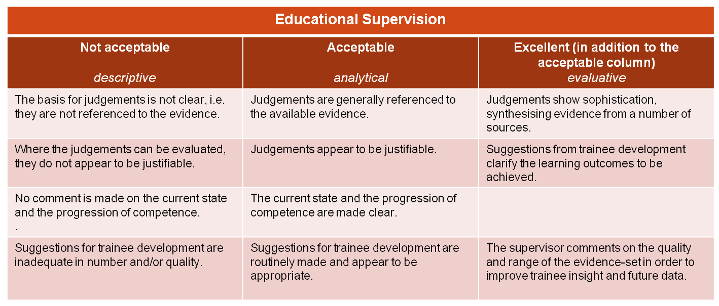

This guidance is designed to follow the e-portfolio’s left hand menu (highlighted in orange) – just go through the items one by one. Extra guidance on some sections is provided in the rounded green boxes. Technical information is provided in the crimson coloured text.
1.REVIEW OBJECTIVES FROM THE LAST POST
- What has been achieved?
- What needs to be carried over?

2.SIGNING DECLARATIONS
- Signing the declarations is important because it satisfies one of the PMETB requirements to enable the trainee to participate in appraisal post CCT. Most of this information can be found on the trainee’s e-portfolio summary page (the first page that comes up after you’ve logged in and selected a trainee.
- Check that they’ve signed the declarations for this post (probity, health, educational contract).
- Make sure you countersigned the educational contract. (This may happen before, during or after the review).

3.LEARNING LOG - LOG ENTRIES: sample some of the entries until you feel you have a general idea about them.
- Numbers: have they logged enough entries (2-3 per week as a rough guide)?
  
  On the e-portfolio:
  Click on ‘Learning Log’ to see some specific entries.
  Under ‘Learning Log’, you’ll see a button (top right corner) to ‘list all entries’ if you wish.
  To see if the entries are of a significant breadth, click on each blue heading at the top and see how many entries in each of clinical encounters, prof. conversations, tutorials, reading, SEA, audit/projects, e-learning and so on.
- Are the recorded entries spread over time? Check to make sure they’ve not all been added at the 11th hour (look at the dates).
- Are they of significant breadth?
- Look at a sample of log entries: is there depth? (i.e. whether a trainee reflects and analyses experience and considers the wider implications like ethics.
- Check the validity of the linkage to professional competencies and curriculum statement headings. Are they appropriate? Remove ones that are not apparent from the written evidence.
- Log entries should on average show:
  - evidence of critical thinking & analysis, describing own thought processes
  - self awareness demonstrating openness and honesty about performance and some consideration of feelings generated
  - evidence of learning, appropriately describing what needs to be learned, why & how
  - appropriate linkage to curriculum
  - demonstration of behaviour that allows linkage to one or more competency areas
- Trainees link each entry to the ‘curriculum statement headings’ (like care of older people, ENT etc). The trainer or educational supervisor links to the ‘professional competencies’ (like practising holistically, ethics, fitness to practise).
- Remember, validation to curriculum statement headings simply means that it is obvious that the written entry is something about that curriculum statement heading – it is NOT a marker of the trainee being competent.
- Some curriculum statements are frequently inappropriately mapped eg 3.2, 3.7 & 4.1. Don’t map to these statements unless you understand what they mean.
- You should only link to a professional competence if the trainee has explicitly written some reflection on that competence.

This table should help you with judging the level of reflection in log entries:
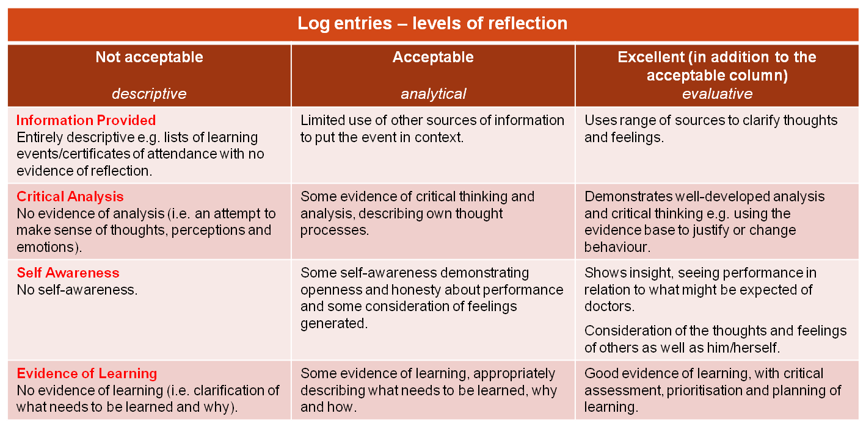

4.LEARNING LOG - NATURALLY OCCURING EVIDENCE
- Significant Event Analyses (SEAs) – there should be 2 per 6m.
  On the e-portfolio:
  Click ‘Learning Log’
  
  From the horizontal menu, select ‘Audit/Project’ or ‘Significant Event Analysis’.
  Ask the trainee where they have logged their reflections from the post and the case presentation.
- One of: Audit / Reflection on QoF / Project.
- (only one of these throughout entire scheme, pref. In 1st GP post)
- Case Study / Presentation - 1 per 6m.
- Reflection on key learning points for each post.
- Encourage the trainee to engage in other NOE like referrals, prescribing analyses etc.

- Significant Events – should be a balance of types: on individual learning, team issues and positive events.
- Audit – should all follow and be assessed on the 8 point audit scale, provided here:
http://www.bradfordvts.co.uk/MRCGP/NOEauditandprojects.htm
- QoF - Reflection on how the practice achieves its QoF score with specific reflection on one chapter heading and suggestions for alternative ways to improve QoF (and clinical quality performance)
- Project - here’s some guidance on how the project should be approached and written up:
http://www.bradfordvts.co.uk/MRCGP/NOEauditandprojects.htm
- Reflection on post - Concise summary of learning points, including reflections on learning achieved (in terms of knowledge, skills and attitudes), and how this relates to a career in GP. This reflection will result in new learning objectives for next posts.
Case Study - can be a presentation of a clinical case study, literature review, a research project, a discussion paper or notes review. The presentation may have been given in a departmental setting or VTS group. Should be relevant to GP. More guidance here: http://www.bradfordvts.co.uk/MRCGP/NOEauditandprojects.htm
- Deanery website – has some very useful specific guidance on all these different types of NOE:
http://www.yorksandhumberdeanery.nhs.uk/general_practice/trainees/NaturallyOccurringEvidenceinePortfolio.aspx

5.LEARNING LOG: OUT OF HOURS - (for those in GP posts only)
- Numbers: have they done the right amount? (6 sessions per 6m in GP)
  On the e-portfolio:
  For OOH, to look at individual sessions, click ‘Shared Log’ and then ‘Out of Hours Sessions’
- Are they of significant breadth (in terms of cases seen)?
- Look at a sample of OOH entries: is there depth? (i.e. whether a trainee reflects and analyses experience and considers the wider implications like ethics).
- Check the validity of the linkage to OOH professional competencies and curriculum statement headings.

As a minimum, trainees should be recording the following for their OOH sessions:
1) The type of session – telephone triage, visiting doctor, base doctor
2) The number of patients seen.
3) A selection of the most interesting patients
4) The significant learning points and,
5) Link these to the curriculum

6.PDP (& EDUCATIONAL COURSES)
- Is the trainee recording and using it properly? : based on learning needs, of a variety, deep and meaningful rather than superficial? The PDP which will give you an impression of (a) how much they’ve engaged with the EP and (b) how committed a learner they are (OR how good they are at ‘talking the talk’ ...or ‘writing the script’).
  
  On the e-portfolio:
  Click on PDP: you should now see a list of complete and outstanding learning tasks.
  There is an option at the top either to ‘view all’ of them or just the ‘active’ ones.
- Is it up to date? (and entries not being added at the eleventh hour)
- Check to see the PDPs are being actioned. Otherwise, what’s the point?
- PDPs need to be SMART (Specific, Measurable, Achievable, Realistic, Time-bound).
- Are there any educational courses the trainee should consider soon? (Available in Yorkshire & Humber: Family Planning, STIF courses, Minor Surgery, Child Health, Consultation Skills, Exit Course, Urgent Care Course, Diversity, nMRCGP preparatory courses)

7.EVIDENCE - CBDs, COTs, CEXs, DOPS
- CBDs, COTS & Mini CEXs: Is there appropriate numbers (i.e. min no. Of WPBA assessments (COTs,, CBDs etc) in the last 6 months?
  On the e-portfolio:
  
  Click ‘Evidence’ and a summary page will come up with all this information. Now click on one of the horizontal menu items to dig deeper. The ‘Skills Log’ option under the Reviews heading is good for a DOPS summary.
- CBDs, COTS & Mini CEXs: Is there a range of contexts? (e.g. mental health, children, etc)
- CBDs, COTS & Mini CEXs: Appropriate challenge?
- Dip into and sample of some of the assessments for both for a general feel of challenge and for evidence of competencies (ones done in GP often more informative than hospital ones).
- Look at the CBD/COT/Mini-CEX mapping sheets. Which competence domains are weak or not demonstrated and therefore the trainee should focus on? Note: ST3s should have strong evidence for all domains.
- DOPs – appropriate for ST stage? In particular, check to make sure ST3s have done all the mandatory ones. Also check to make sure the right people are signing these off i.e. senior level staff and not the trainee’s ‘mates’ or peers.
- CBDs/COTS - To check for context (like child health, mental health, elderly, palliative care): look at the trainee’s CBD and COT mapping sheets (often uploaded).
- CBDs/COTs -To assess level of challenge: dip into a sample of some of the assessments and read the description of events.
- CBDs: when looking at the competency grades, remember that those CBDs done in GP are often more reliable and valid than those done in the hospital setting.
- DOPS: make sure ST3s have done all the mandatory DOPS. DOPS on manikins in isolation don’t count!
- Mini-CEXs: again check that the trainee is not using their peers to assess them. Must be senior level staff.
This document tells you what needs to be done at what ST stage:
- http://www.bradfordvts.co.uk/ONLINERESOURCES/00.%20NMRCGP/which%20assessments%20at%20what%20ST%20stage.doc

8.EVIDENCE – Clinical Supervisor’s Report (CSR) & Educator Notes
- Look at the CSR – what are the themes that come through in each of the RDM-p domains? (R=relationship, D=diagnostic/decision making skills, M=management, p=professionalism (attitudes)
  On the e-portfolio:
  To view CSR – click on ‘Evidence’, then click CSR
  Click ‘Educator Notes’ from the main left hand navigation menu
- Look at the ‘Educator Notes’ and see if there are any similar themes (=triangulation) or anything else.
- You might wish to dip into previous CSRs to view progress on the RDM-p domains.
- Management is about organisational things like leading people, managing one’s own time etc. It is not clinical management!

9.EVIDENCE – MSFs and PSQs – details on how to release the MSF results are on www.bradfordvts.co.uk
- MSF – check the trainee’s aggregate score for professional behaviour and clinical ability and see if it is above or near the peer mean. Then look at it in more detail to see if any other themes (good and bad) emerge.
  On the e-portfolio:
  Click ‘Evidence’ then select ‘PSQ’ or ‘MSF’
  Click the ‘analyse’ icon. You may need to ‘release the results’ (at the bottom) to enable the trainee to see them under their log in.
- PSQ – are the component scores above or near the peer mean? Look for any other themes (good and bad).
- Comments: in general, be wary of ‘one off’ comments. Look for themes derived from similar comments made by several individuals
- The aggregate scores can be found at the bottom of each table presented in the MSF. But don’t forget to look at the other elements and compare those too – a trainee might have an overall score higher than their peers but a significant deficiency in one particular area. Tip: click the icon of a little graph, to give you the collated results, rather than clicking the icon on the right which gives the individual ones (tedious and less informative).
- MSF: especially look at professional attitudes and behaviour.
- ITPs (Innovative training Posts – often called modular or community posts by some schemes) - if the ITP has a primary care component (with some modular experience elsewhere) then a PSQ should be completed. This is non-negotiable and will lead to unsatisfactory progress if not completed.

10.CURRICULUM COVERAGE
- Is there a reasonable coverage of the GP curriculum areas in light of where the trainee is at in their training scheme? (Review what posts have been done). Bear in mind that some areas are often difficult to achieve (e.g. learning disabilities and genetics).
  On the e-portfolio:
  Under Reviews select ‘Curriculum Coverage’
- Click on some of the curriculum statement headings and sample some of the log entries. Is the linkage appropriate?
- Look at the weak areas: can these be achieved in the remainder of their scheme?

11.REVIEWS – Self and ES Rating of Competencies
- Trainee’s self rating scale: check to see if the ‘comments’ box contains adequate there evidence to back up the grades they have awarded themselves?
  On the e-portfolio:
  Under the ‘Review’ heading in the left hand navigation menu, either click:
  - ‘Trainee self rating’ to see their scores or
  - ‘Record ratings’ if you want to add yours
- Your rating: Make sure you mark the rating scales in relation to the evidence too(e.g. for competent in practising holistically, the comments box might say ‘6 out the last 8 CBDs marked as competent’).. Write as much evidence to justify your rating as you can.
- This document is really useful for figuring out where to look for the evidence:
http://www.bradfordvts.co.uk/ONLINERESOURCES/00.%20NMRCGP/ED%20SUPERVISION%20AND%20ARCP/evidence%20for%20rating%20scales.doc
- If there is a large variance between yours and the trainee’s ratings, discuss to synchronise your wavelengths.

12.PROGRESS TO CERTIFICATION – ONLY complete if ST3 trainee moving to CCT.
- Please make sure the CPR/AED cert is ticked and not expired.
- Please check to make sure the OOH requirement ticked? (check hours of engagement)
- All professional competencies should now be marked as competent. Check the CBD/COT mapping forms to make sure this is the case.

13.THE PERSON AND THE POST
- Ask how it is going. Are there any problems at work? In particular, have there been any complaints or critical incidents (which might be recorded under learning log> professional conversations?
- Find out if the job is providing adequate clinical experience and adequate educational experience. For instance, are they being allowed release for HDR (HDR attendance rate should be around 70%)? If not, what alternative protected educational time is being provided instead?
- Also find out whether there are any personal difficulties they’d like to talk about: social, finances and health. How open the trainee is depends on the ethos you have set and the relationship you’ve built up with them.
- Statement of leave – find out how much leave they’ve taken in this job so far (above that of study and annual leave allowed). In particular, ask about: Sick, Maternity, Paternity, Carer Leave, Adoptive Leave. They should have filled out a statement of leave form. It’s important to ask about this because if the leave mounts to more than 2 weeks, it needs to be made up.

14.AGREED PLAN FOR THE NEXT POST – this goes into the last box of the e-portfolio’s ESR form
- Curriculum – which areas do they need to concentrate on for the next post?
- Educational courses they are planning to consider
- Evidence – how can they improve on quality of the evidence in the next post? Concentrate on the evidence which they have control over: how they approach/write up their learning log entries, SEAs, Case Presentations, Projects/Audit, Reflections on the post and PDPs.
- Themes from MSF/PSQ/CSR – that need working on.
- Anything in ‘The Person and the Post’ section that needs resolving.

A note on those Out of Programme (OOP)
When out of programme either an ES review can be done by the ES at the beginning of the period of leave, and if there is substantial evidence submitted in that review period then should comment upon it and record progress, and set out the development plan to be followed on return to the programme. Alternatively an ES review giving an OOP outcome can be created by the Deanery administrator when the trainee is out of programme so that the ARCP panel can record the exact dates out of programme and give an Out of Programme outcome (outcome 8). A further ES review should be undertaken when the trainee returns to the programme to ensure the personal development plan is appropriate.

If there are any problems with this form, email me on rameshmehay@googlemail.com

